**7 – DAY FREE MASTERCLASS**

**AWS TRAINING – ETHNUS CODEMITHRA**

NAME : R. BHARATHI KANNAN

COLLEGE : VIT UNIVERSITY, VELLORE

**SCREENSHOTS:**

1-Login Screen

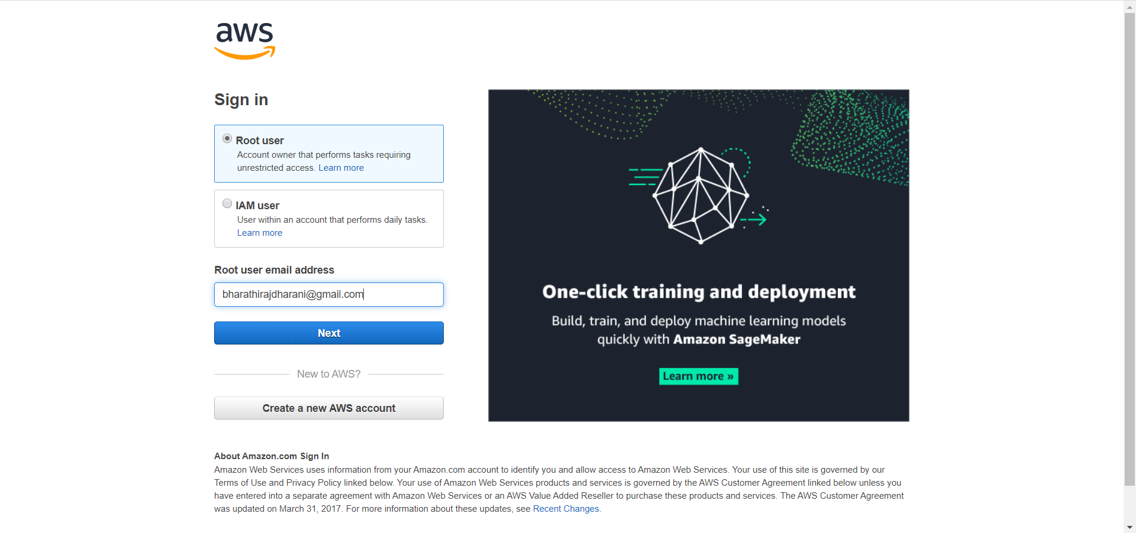

2- EC2 Dashboard

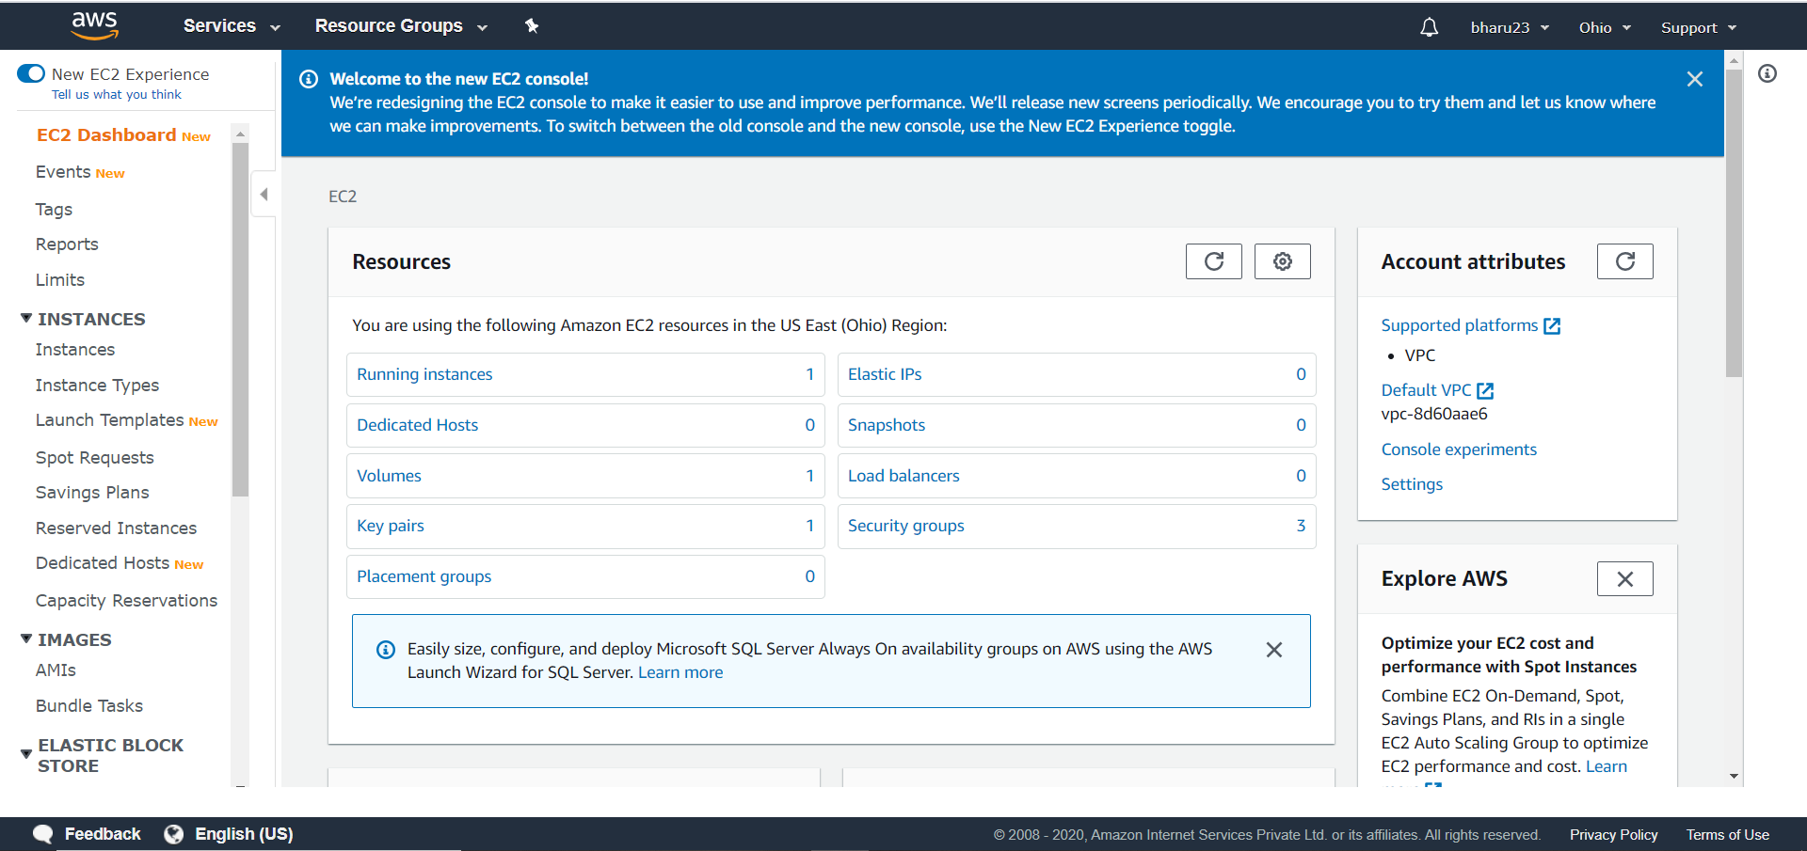

3- S3 Dashboard

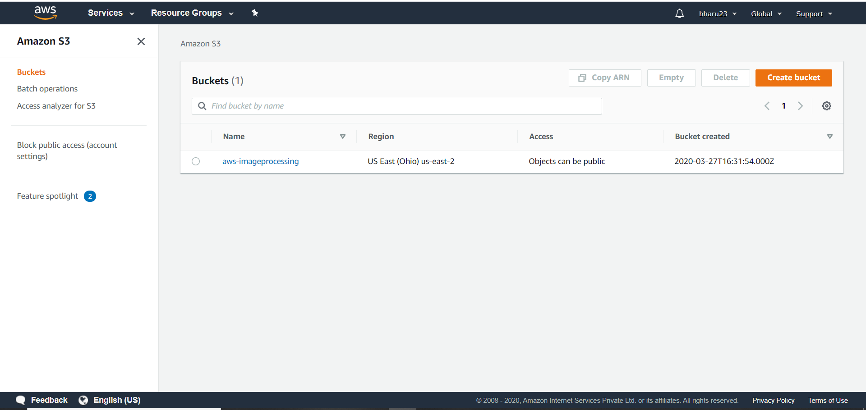

4-Rekognition Dashboard

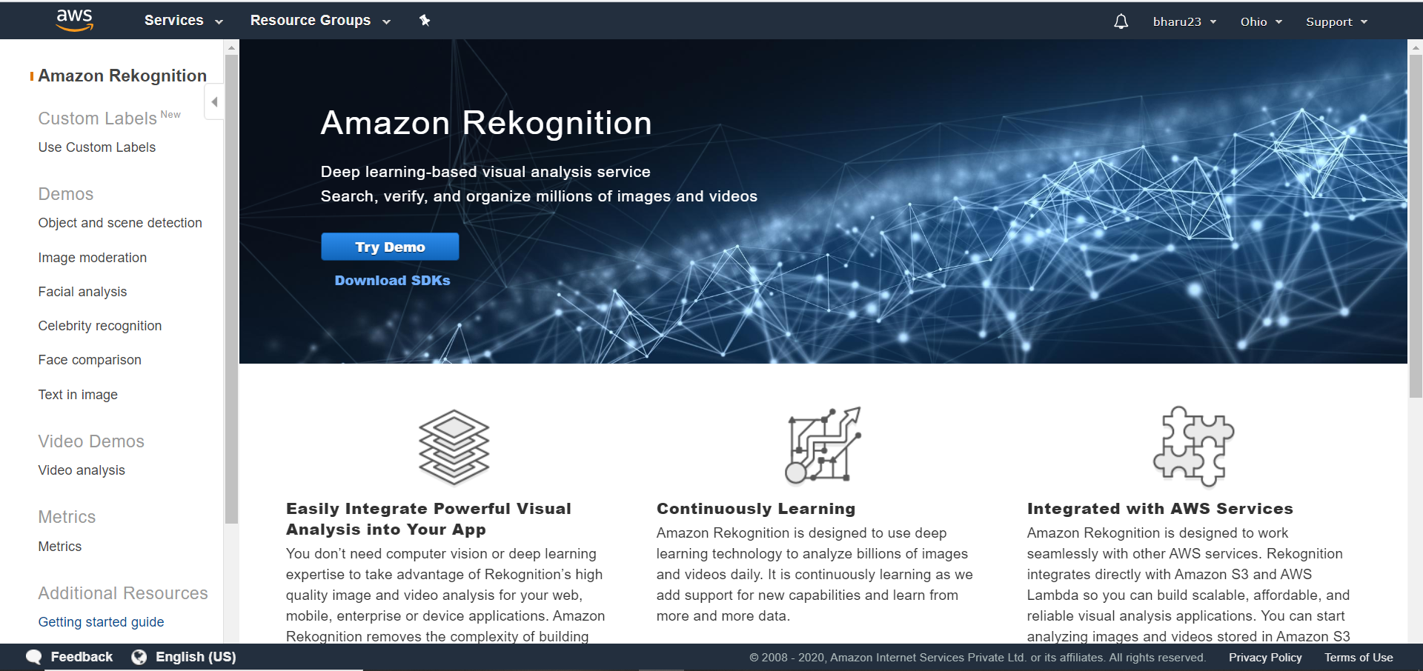

EC2

5- Choosing an AMI

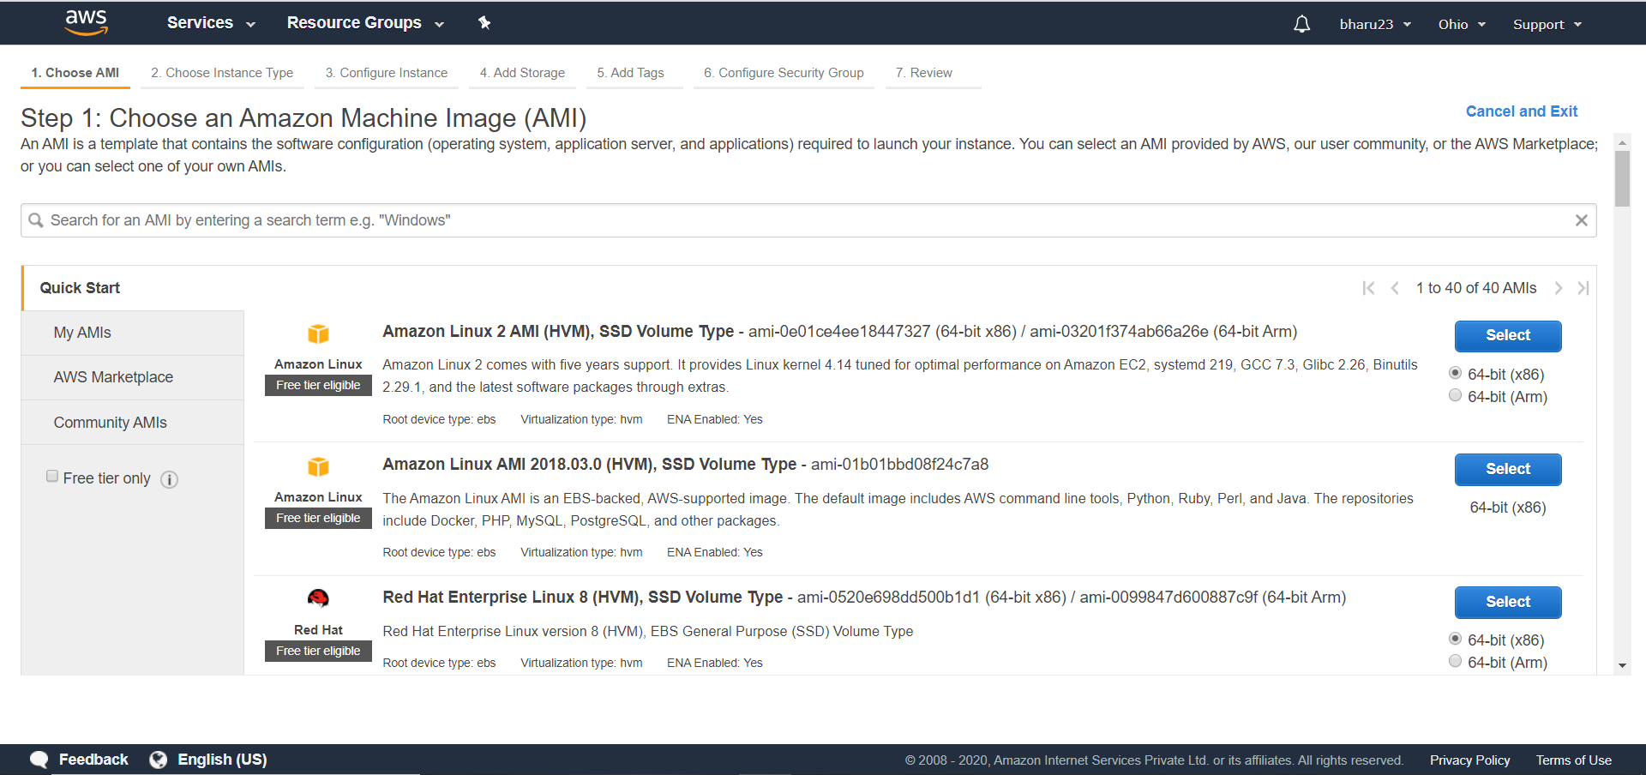

6- Choosing an Instance Type

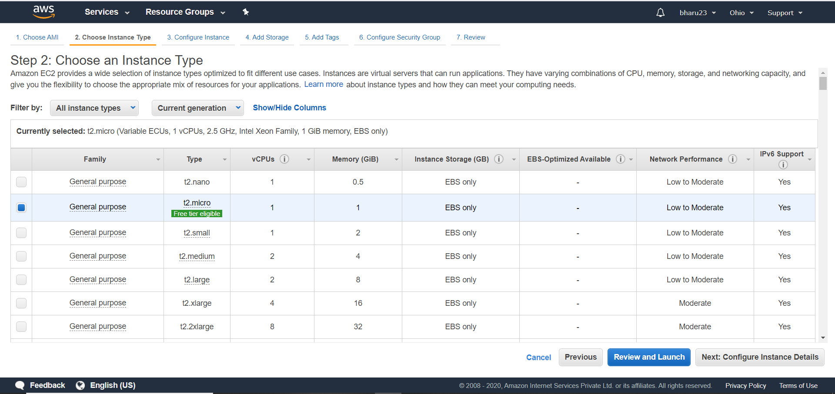

7- Adding Storage

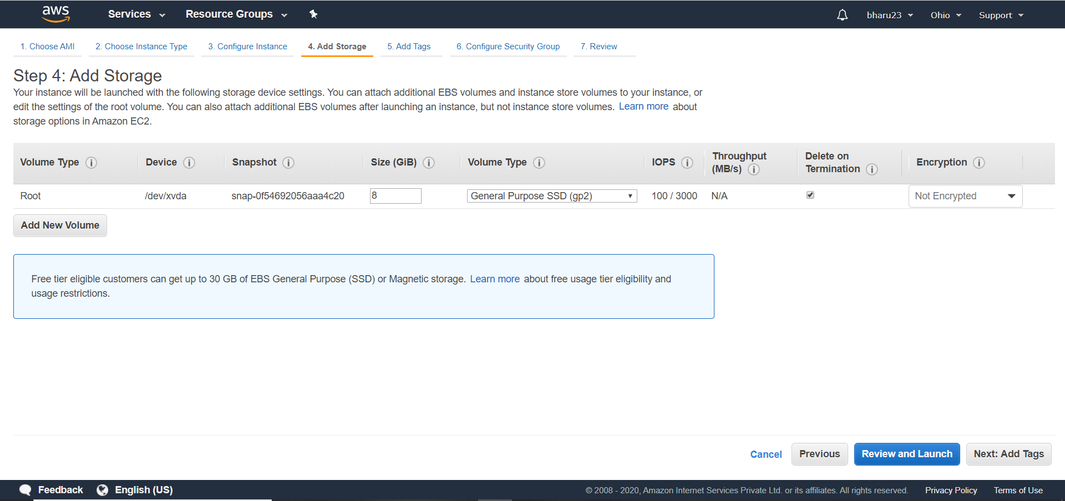

8- Configuring Security Groups

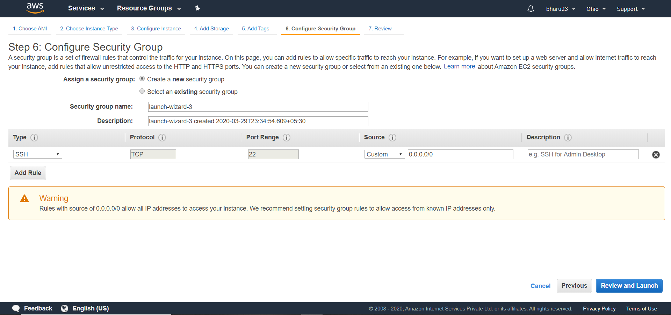

9- Key-Pair Download

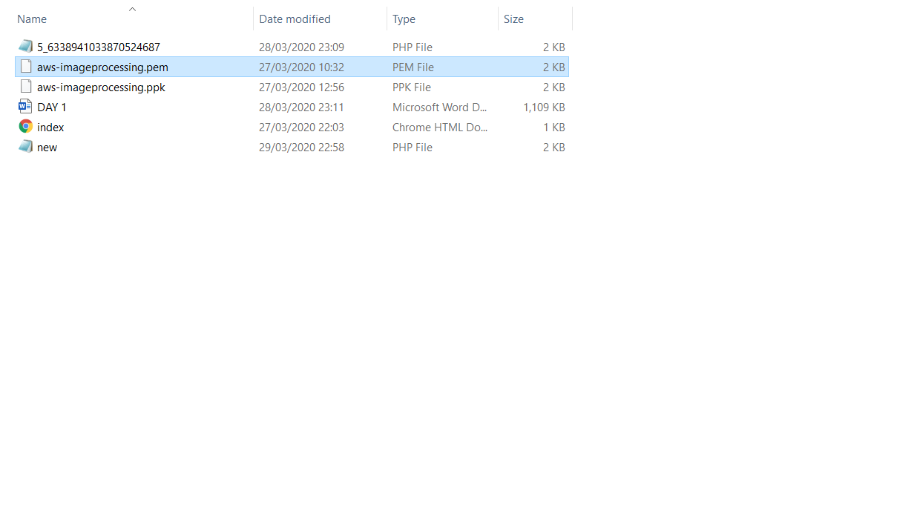

10 – PuTTYgen Conversion from .pem to .ppk

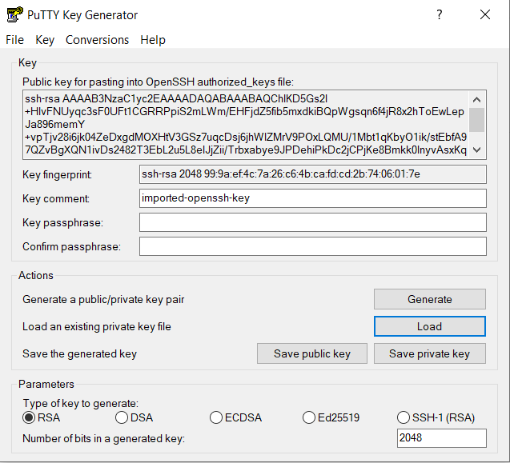

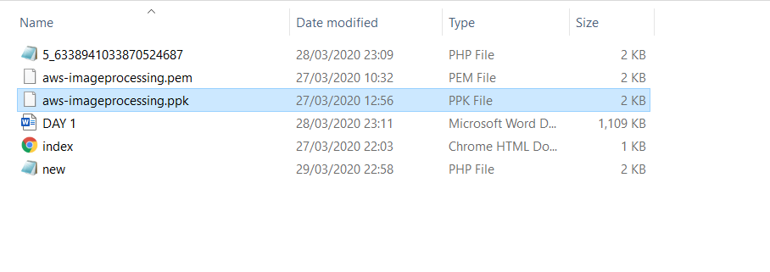

11- Logged In EC2 Black Screen

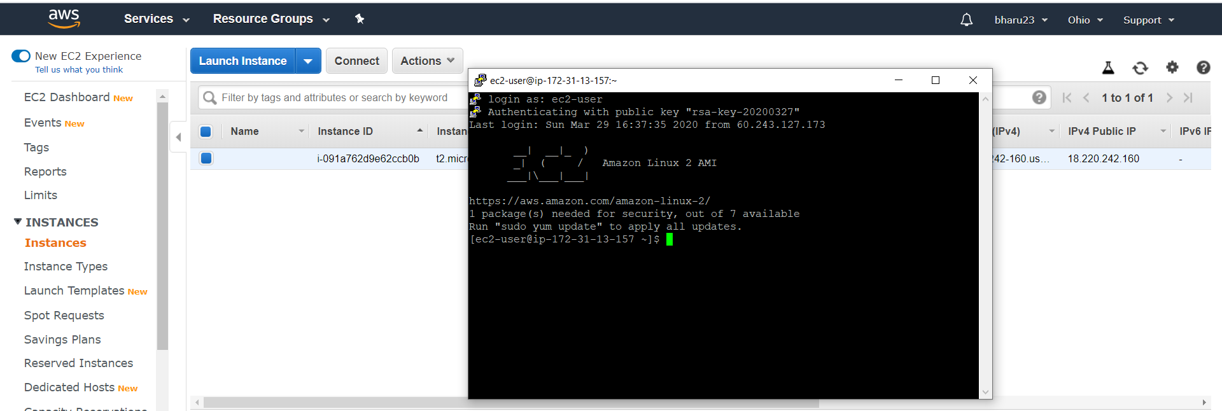

S3

12- Creating a Bucket

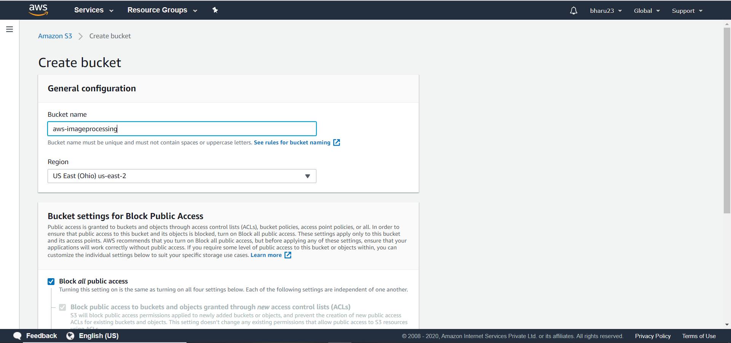

13- Uploading a Object

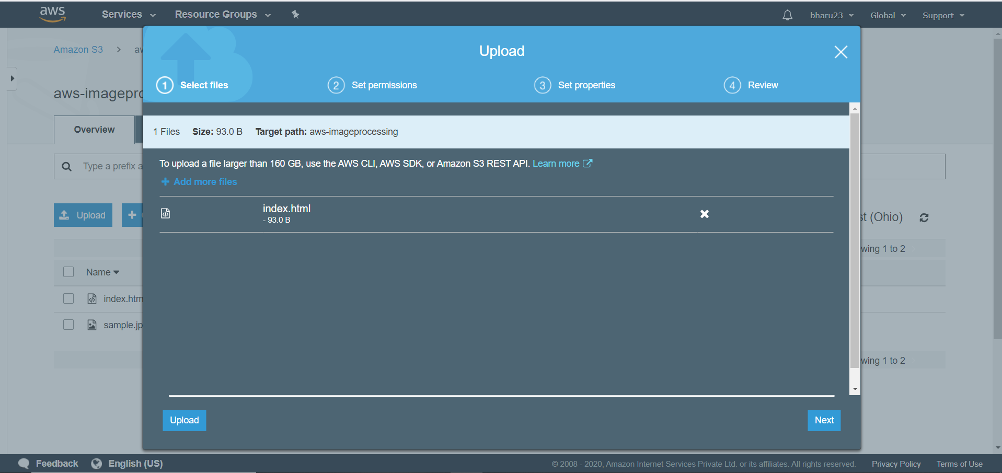

14 – Enabling Static Website

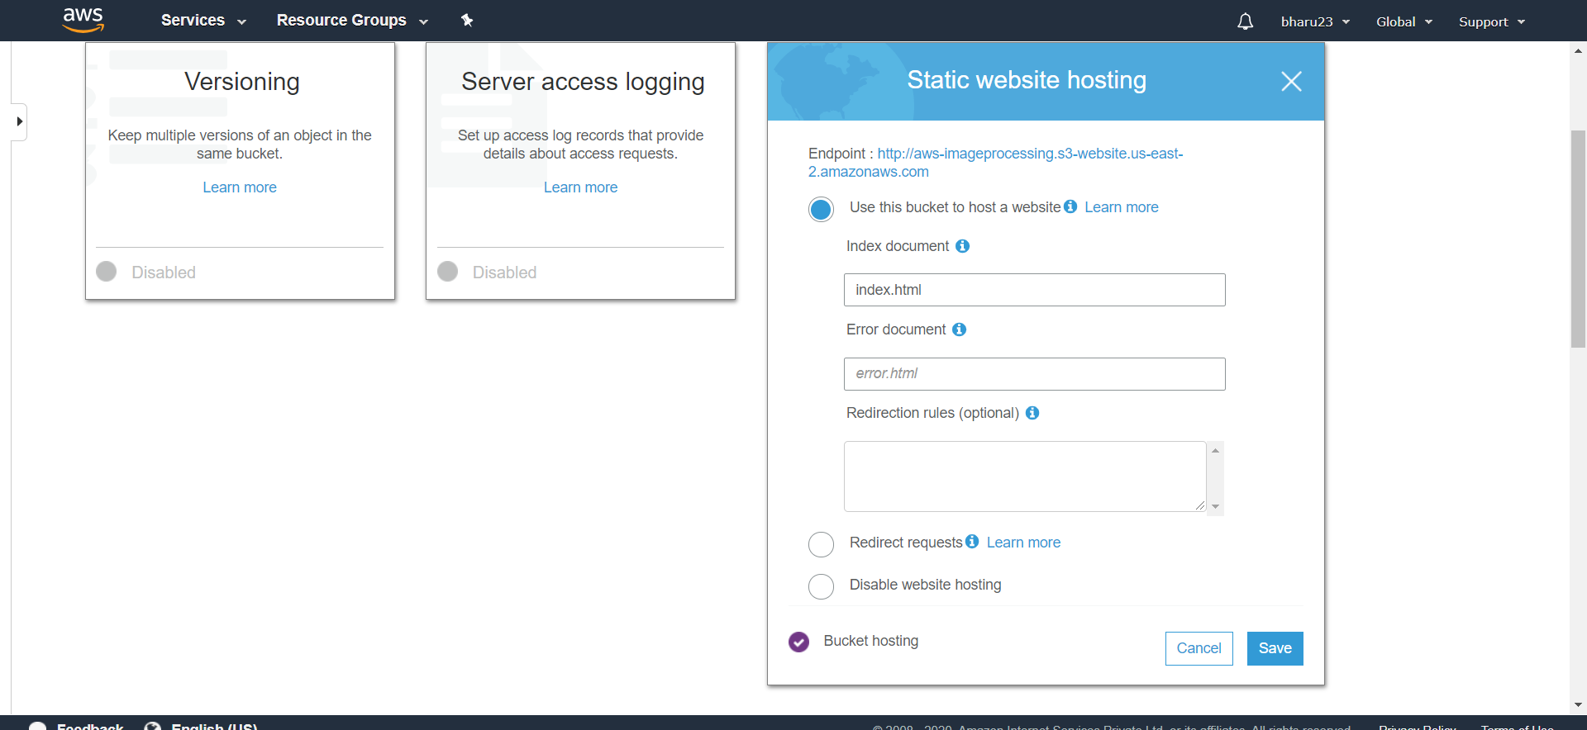

15-Making the Object Public

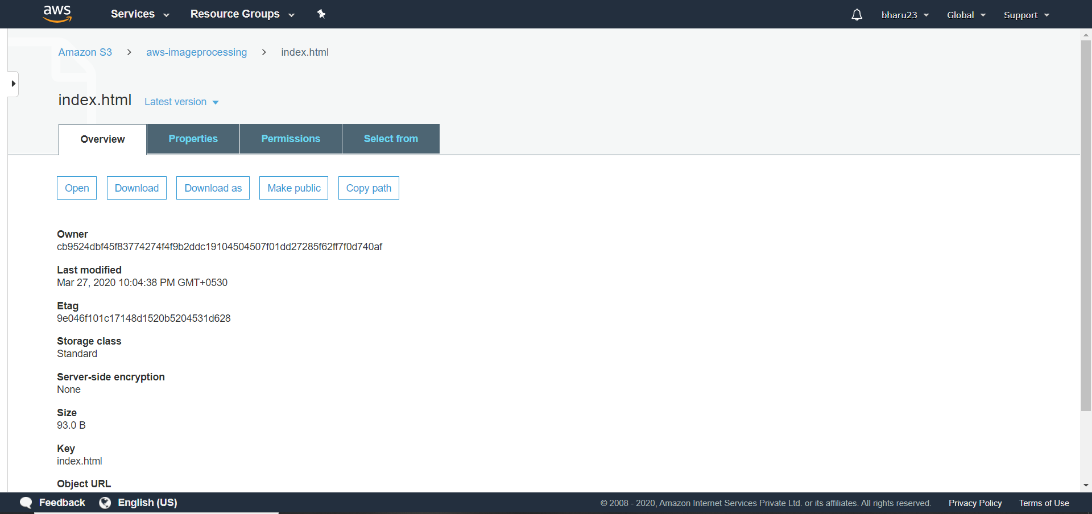

16-Checking the S3 on the Browser

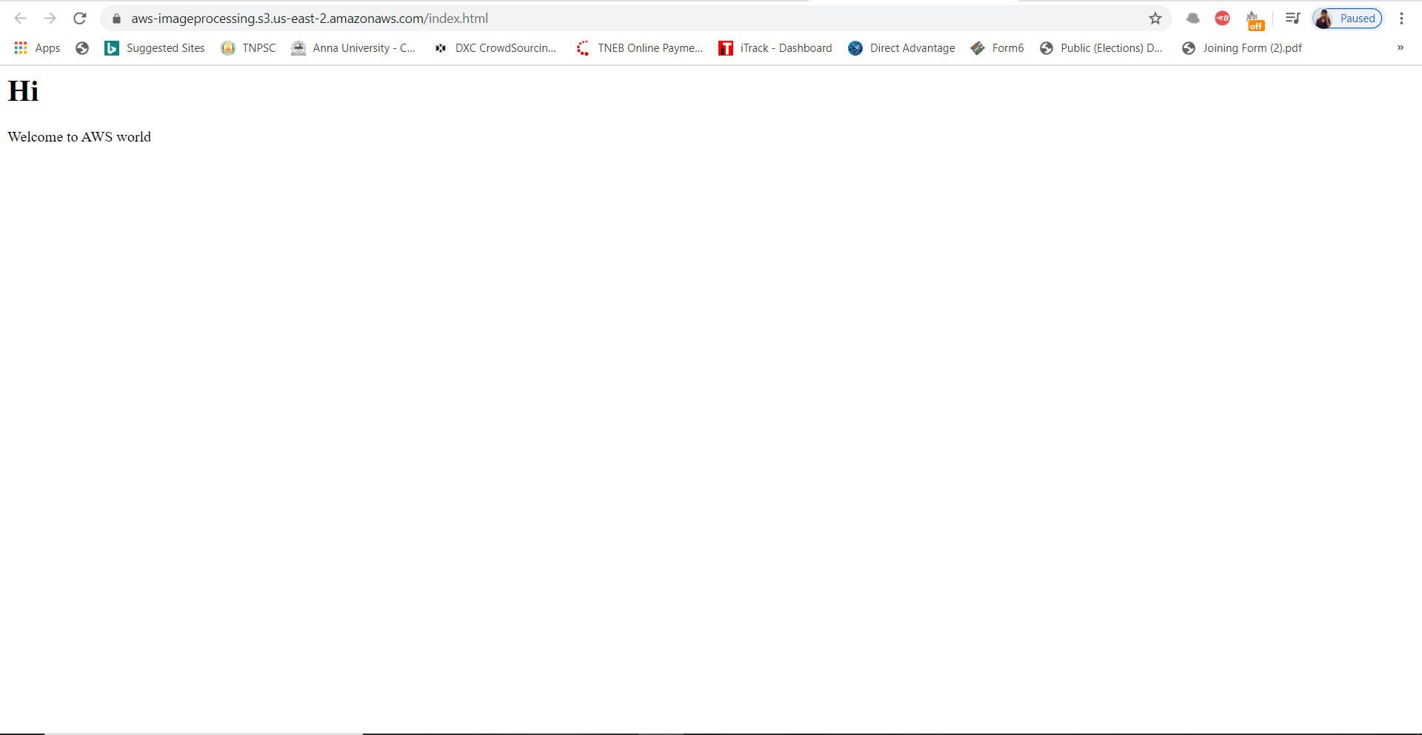

REKOGNITION

17-Face Detect

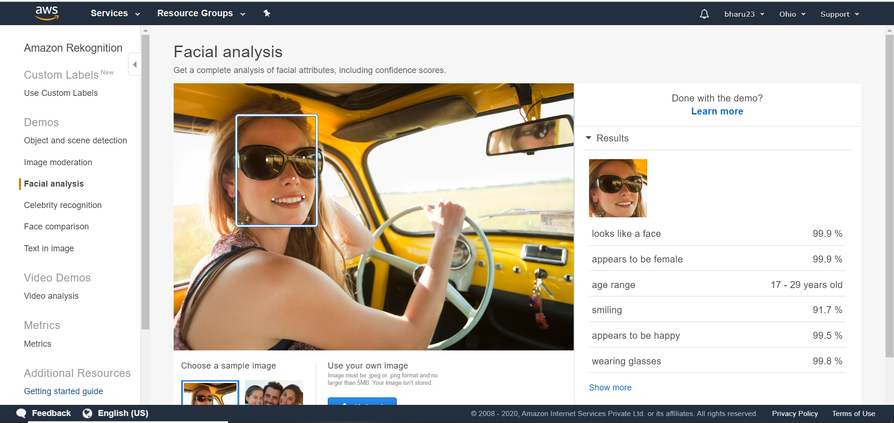

18-Face Compare

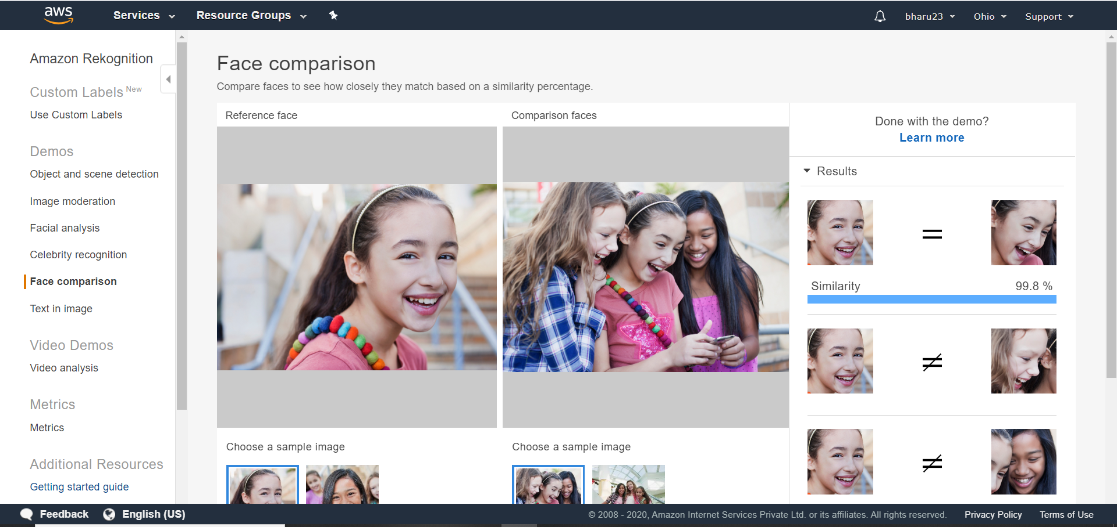

19-Celebrity Recognition

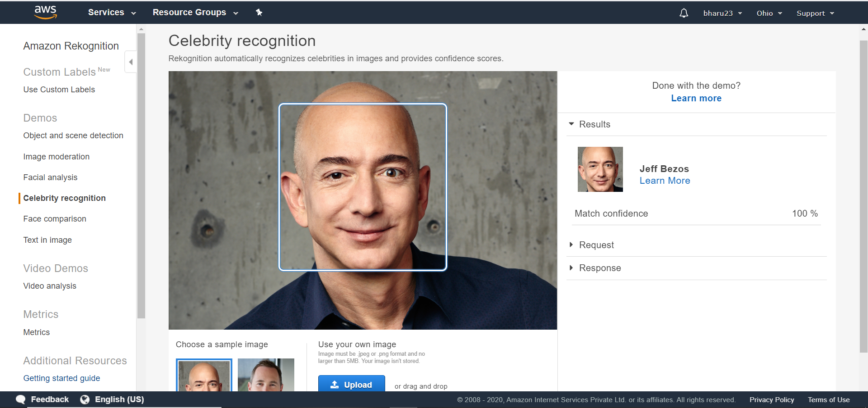

20-Text In Image

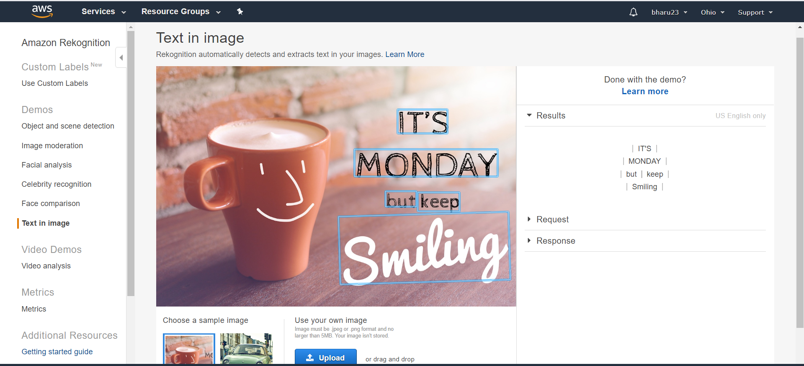

EC2 & S3

21-Installing aws-sdk

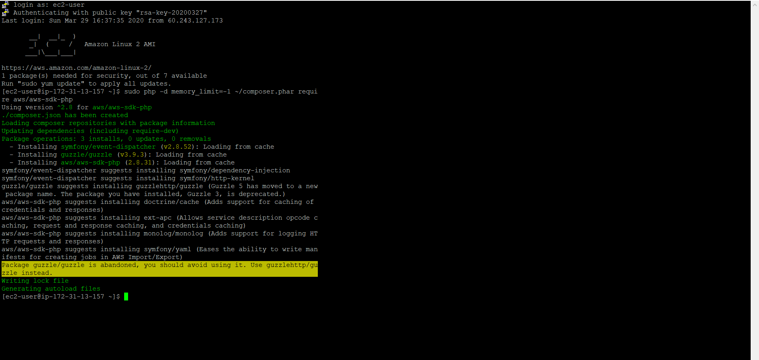

22- Installing php

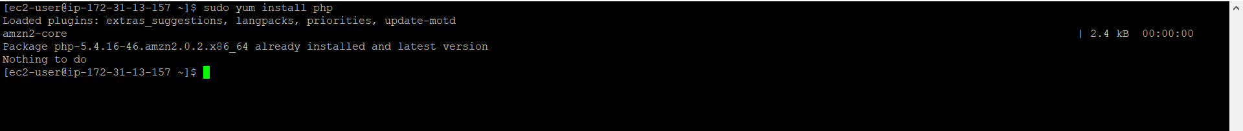

23- Index.php Code

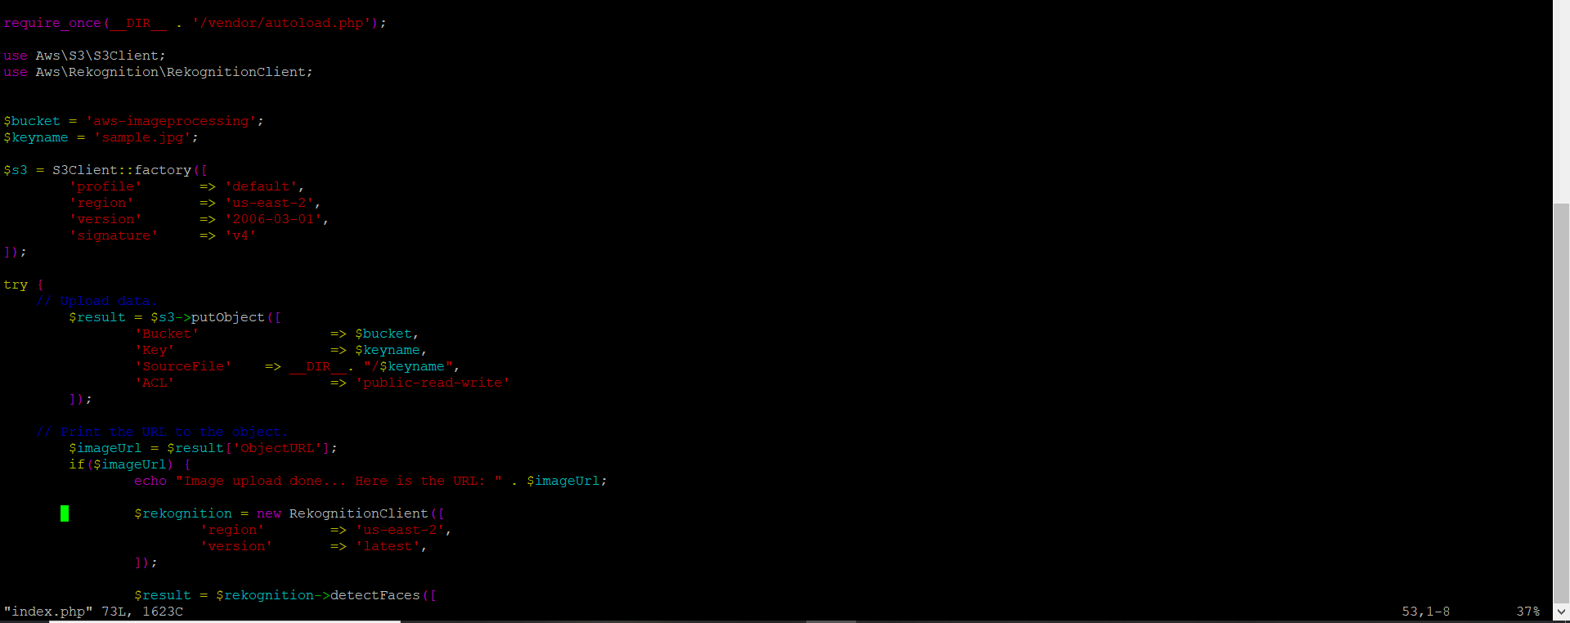

24- Upload Success

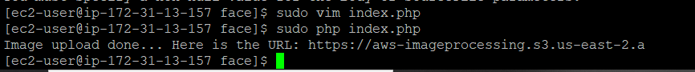

EC2 & REKOGNITION

25- Face Detect Success (I’m getting Fatal Error).

